**IMPLEMENTATION OF EVENT HANDLING**

**AIM:** Write a java program to demonstrate the use of textfields, radiobuttons, and button.

**PROGRAM**:

/**

*

* @author 2162014

*/

import java.awt.Color;

import java.awt.Font;

import java.awt.event.ActionEvent;

import java.awt.event.ActionListener;

import javax.swing.JButton;

import javax.swing.JFrame;

import javax.swing.JLabel;

import javax.swing.JPanel;

import javax.swing.JRadioButton;

import javax.swing.JTextField;

class Calculator implements ActionListener {

// Create a JFrame to hold the calculator components

JFrame frame = new JFrame("Calculator");

// Create labels for input and output fields

JLabel input1Label = new JLabel("Num 1:");

JLabel input2Label = new JLabel("Num 2:");

JLabel resultLabel = new JLabel("Result:");

// Create input and output fields

JTextField input1Field = new JTextField();

JTextField input2Field = new JTextField();

JTextField resultField = new JTextField();

// Create buttons

JButton addButton = new JButton("Add");

// Create panel to hold the components

JPanel panel = new JPanel();

// Create radio buttons for background color

JRadioButton yellowButton = new JRadioButton("Yellow");

JRadioButton greenButton = new JRadioButton("Green");

// Create fonts for labels, input and output fields, and buttons

Font sansSerif = new Font("SansSerif", Font.BOLD, 20);

Font serif = new Font("Serif", Font.BOLD, 20);

Font bgFont = new Font("SansSerif", Font.BOLD, 14);

Calculator() {

// Set the layout for the panel

panel.setLayout(null);

// Set the size of the JFrame

frame.setSize(400, 450);

// Make the JFrame exit on close

frame.setDefaultCloseOperation(JFrame.EXIT_ON_CLOSE);

// Make the JFrame visible

frame.setVisible(true);

// Set the position of the labels and input and output fields

input1Label.setBounds(50, 50, 150, 30);

input2Label.setBounds(50, 100, 150, 30);

resultLabel.setBounds(50, 150, 150, 30);

input1Field.setBounds(200, 50, 150, 30);

input2Field.setBounds(200, 100, 150, 30);

resultField.setBounds(200, 150, 150, 30);

// Set the position of the buttons

addButton.setBounds(150, 250, 80, 30);

// Set the position of the radio buttons

yellowButton.setBounds(50, 350, 80, 30);

greenButton.setBounds(250, 350, 80, 30);

// Set the font of the labels, input and output fields, and buttons

input1Label.setFont(sansSerif);

input2Label.setFont(sansSerif);

resultLabel.setFont(sansSerif);

input1Field.setFont(serif);

input2Field.setFont(serif);

resultField.setFont(serif);

addButton.setFont(sansSerif);

yellowButton.setFont(bgFont);

greenButton.setFont(bgFont);

// Add components to the panel

panel.add(input1Label);

panel.add(input2Label);

panel.add(resultLabel);

panel.add(input1Field);

panel.add(input2Field);

panel.add(resultField);

panel.add(addButton);

panel.add(yellowButton);

panel.add(greenButton);

// Add the panel to the JFrame

frame.add(panel);

// Register listeners for buttons and radio buttons

addButton.addActionListener(this);

yellowButton.addActionListener(this);

greenButton.addActionListener(this);

}

// Handle button clicks

@Override

public void actionPerformed(ActionEvent e) {

if (e.getSource() == addButton) {

int x = Integer.parseInt(input1Field.getText());

int y = Integer.parseInt(input2Field.getText());

int sum = x + y;

resultField.setText(Integer.toString(sum));

} else if (e.getSource() == yellowButton) {

panel.setBackground(Color.yellow);

greenButton.setSelected(false);

} else if (e.getSource() == greenButton) {

panel.setBackground(Color.green);

yellowButton.setSelected(false);

}

}

}

public class UI_demo {

public static void main(String[] args) {

new Calculator();

}

}

**OUTPUTS**:

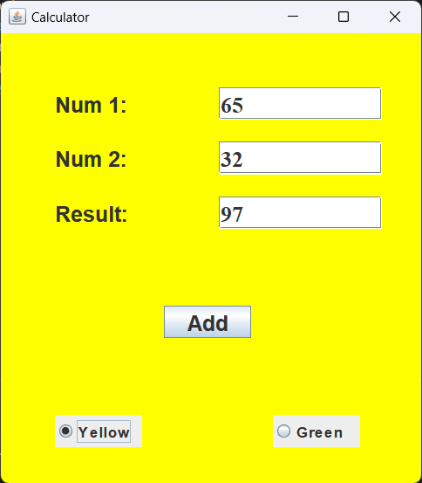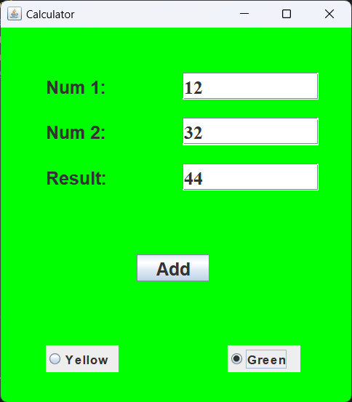

**RESULTS:**

The java program was created successfully to demonstrate the use of textfields, radiobuttons, and button.